Dear Parents/Caregivers,

As leaders of the WOW Team, the Year ---- class are working towards improving the school’s recycling, and reducing waste going to landfill with educational presentations to the R-5 classes.
----- class is already running composting for the R-5 classes, and classrooms also now have an official recycling crate. The main reasons for this focus are that:

- Recycling and waste reduction conserves natural resources and energy, and ensures the sustainability of our planet.
- Developing recycling and waste reduction skills in students is important learning.
- Waste going to landfill is far more costly to the school than recycling, so minimising waste means there will be more money for learning resources and teaching support.

Less to Landfill Challenge!
The classes have been invited to try to fit the entire class’s daily landfill waste into a tiny, 15cm tall bin! This emphasizes that every piece of packaging that we can save from landfill makes a difference. As part of the Challenge, all R-5 classes are holding a ‘Nude Food’ day to focus on minimizing food and packaging waste, which is the main component of school waste that has to go to landfill. This is where you can help!

On NUDE FOOD DAY – (Insert date)

Try to pack: A Waste-Less Lunchbox  - Snacks & drinks in reusable containers. This  includes zip lock bags which can be washed and  reused many times.  - Reusable utensils when needed.  - A reusable lunchbox or backpack.  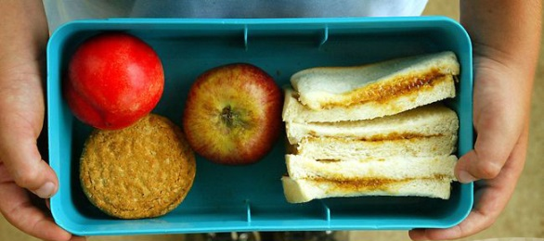 | Avoid: A Disposable Lunchbox  - Lunches packed in plastic bags or cling wrap,  foil or wax paper that cannot be reused.  - Disposable forks and spoons.  - Pre-packaged single-serve snack items.  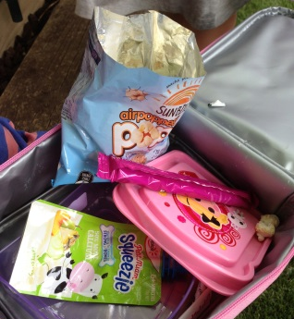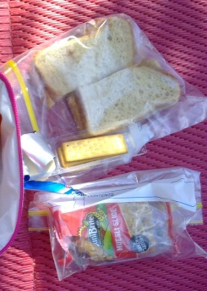
We appreciate your support!

