Dear Parents/Caregivers,

Every piece of packaging or excess food that we can save from landfill makes a difference. As part of the Wipe Out Waste schools Less to Landfill Challenge, [ insert site or class name] is holding a waste less (or Nude) food day on [ insert date/day] to focus on reducing the amount of material that we send to landfill.
When planning lunches for this day, and throughout the year, please help us minimise food and packaging waste by packing a waste-less lunch!

Try to pack: A Waste-Less Lunchbox  - Snacks & drinks in reusable containers. This  includes zip lock bags which can be washed and  reused many times.  - Reusable utensils when needed.  - A reusable lunchbox or backpack.  - Small pieces of fruit, yoghurt or snack items in  a reusable container.  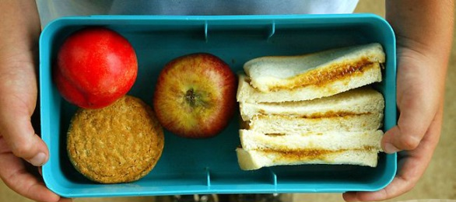 | Avoid: A Disposable Lunchbox  - Lunches packed in plastic bags or cling wrap,  foil or wax paper that cannot be reused.  - Disposable drink boxes, pouches, cans, cartons  and bottles.  - Disposable forks and spoons.  - Pre-packaged single-serve snack items.  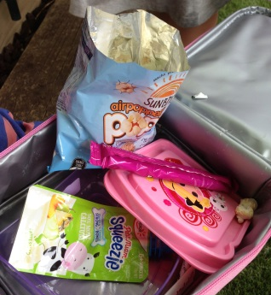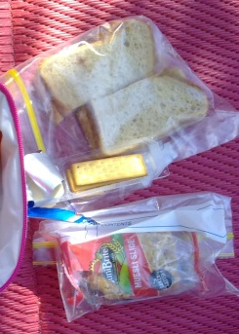

Here are a few more suggestions: (you may wish to add a tip each week in the school newsletter)

- Help children to make nutritious, waste-less lunches and let them make their own lunches. Try packing lunches the night before and storing them in the fridge overnight.
- Discuss with your child what they like to eat and how much. Bin audits in schools across SA show large quantities of unopened pre-packaged foods, including single-serve yogurts, cheese sticks, sandwiches, uneaten fruit and many near full fruit boxes being thrown away. This costs your family money as well as creating waste.
- Cut up fruit and vegetables and pack them in reusable containers so that children can eat some and save the rest for later. For example, it's hard to take some bites from a big apple at recess and save the rest for lunchtime. It's easier to eat a wedge or two and then reseal the container. A rubber band around sliced apple will prevent browning.

- Encourage your children to bring home uneaten food to eat after school. Appreciate that play time is also important, so discuss with children how much they can reasonably eat in one day. Often children throw uneaten food away because they don’t want to upset the person who packed the lunch. If you’re not sure how much they can eat at school, start small. eg a piece of fruit and a sandwich, and build it up if they are asking for more.
- If your children have chips, savoury biscuits, or other snacks, try buying a larger bulk pack (rather than the more expensive so called ‘convenience’ packs with lots of packaging) and have your children put the same quantity into a reusable labelled container that they bring home each day.
- Avoid buying drinks in packaging that cannot be resealed. Many children take just a few sips at snack time and discard the rest.
- Reducing the cost for disposal of food packaging at school means more money to spend on learning resources and teaching support.

For more information, please contact [ insert name ]

Sincerely,

[ insert name ]

